**Assembly Instructions:**

**Final Product:**

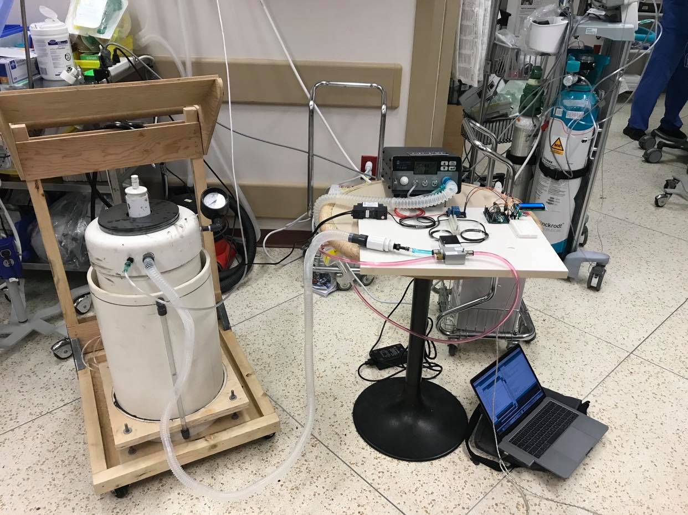

The system will involve modifications made to 2 PVC pipes. The ventilator will look like this:

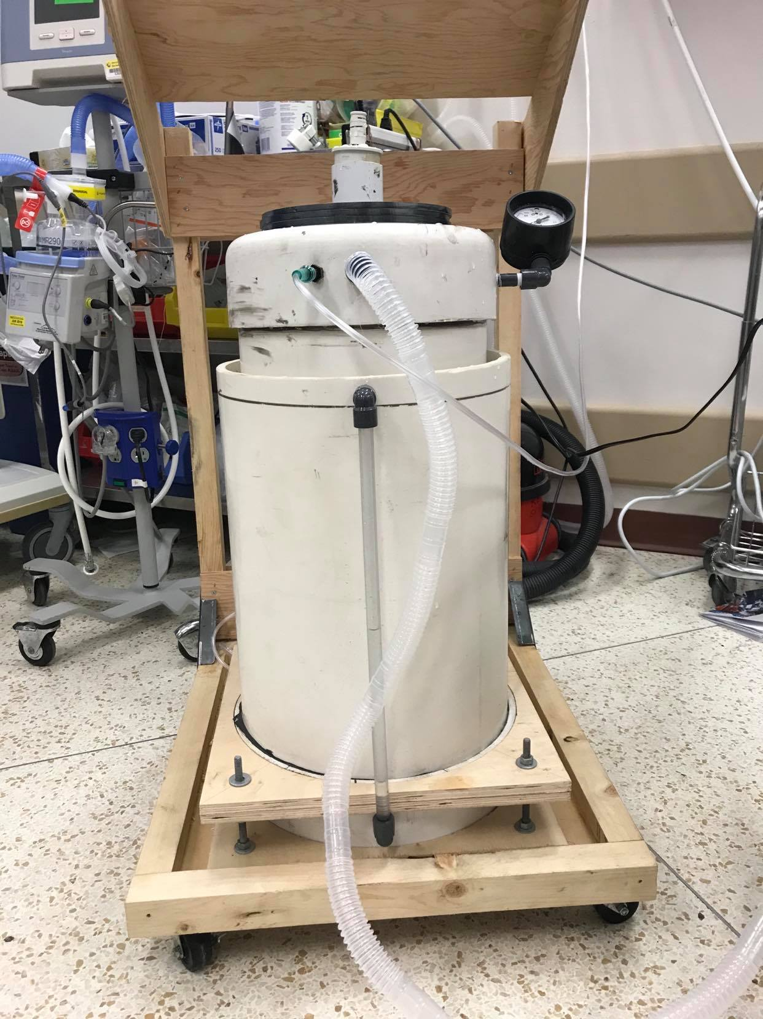

Pipe **#1** (10” diameter, sits inside the larger pipe):

1. Glue a 10” cap onto one end of the pipe using pipe cement. This end is now the **top** of this pipe.

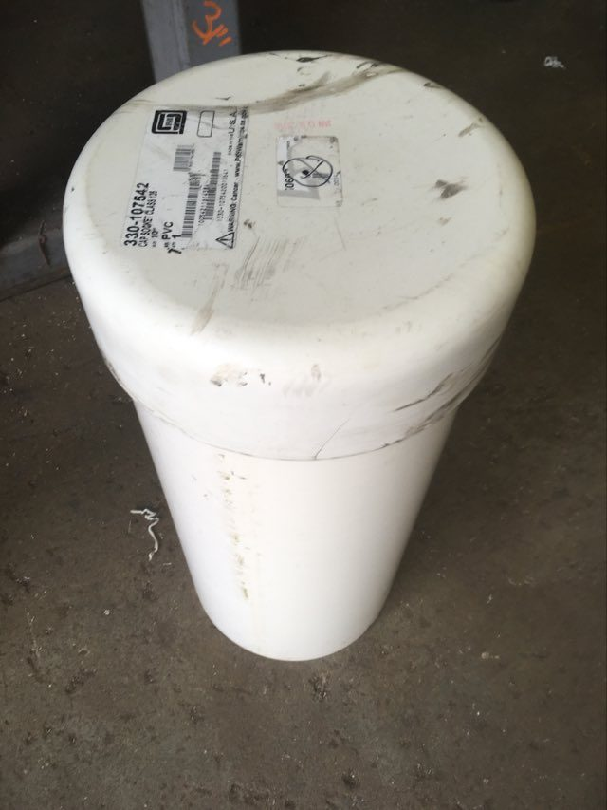

2. Dill and tap 1 x ¼” hole 2-3cm from the **top** of pipe **#1** (through the side of the cap).

*a.* Thread in a PVC ¼” thread to ¼” hose barb nipple, using Teflon tape. \**This port will be used to connect the system to hospital air/O2.*

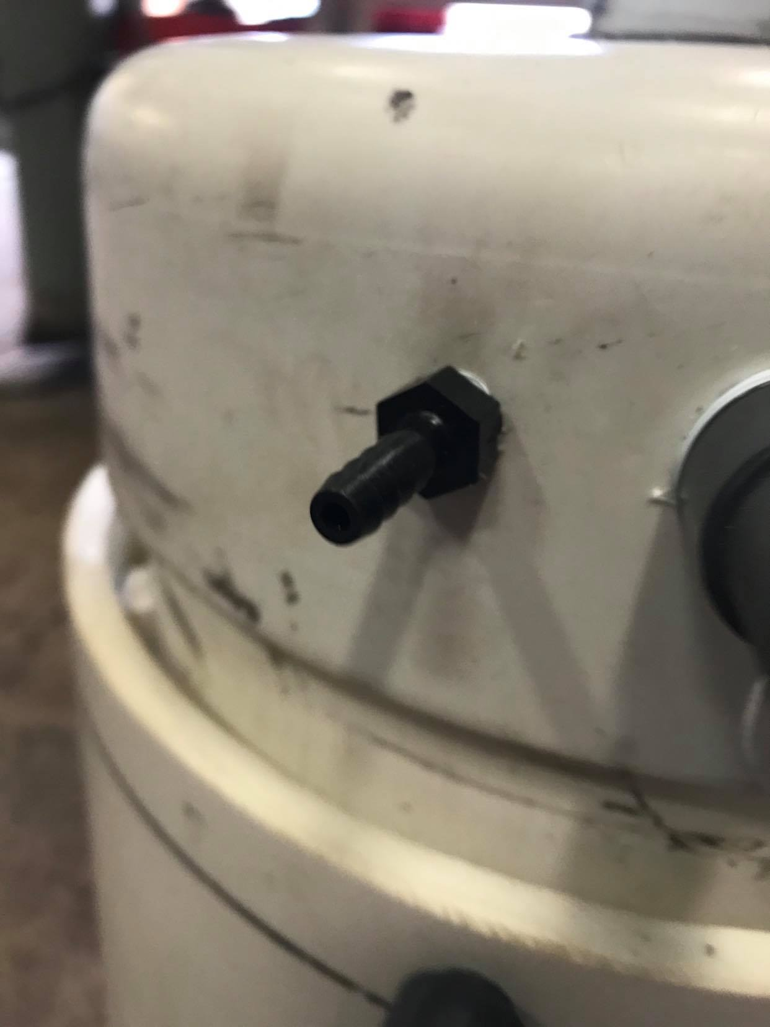

3. Drill and tap 1 x ¾” hole 2-3 cm from the **top** of pipe **#1** (through the side of the cap).

a. Thread in a PVC ¾” thread to 22mm straight pipe, using Teflon tape.

b. \**This port will be used to connect the system to the patient, via 22mm diameter hospital tubing.*

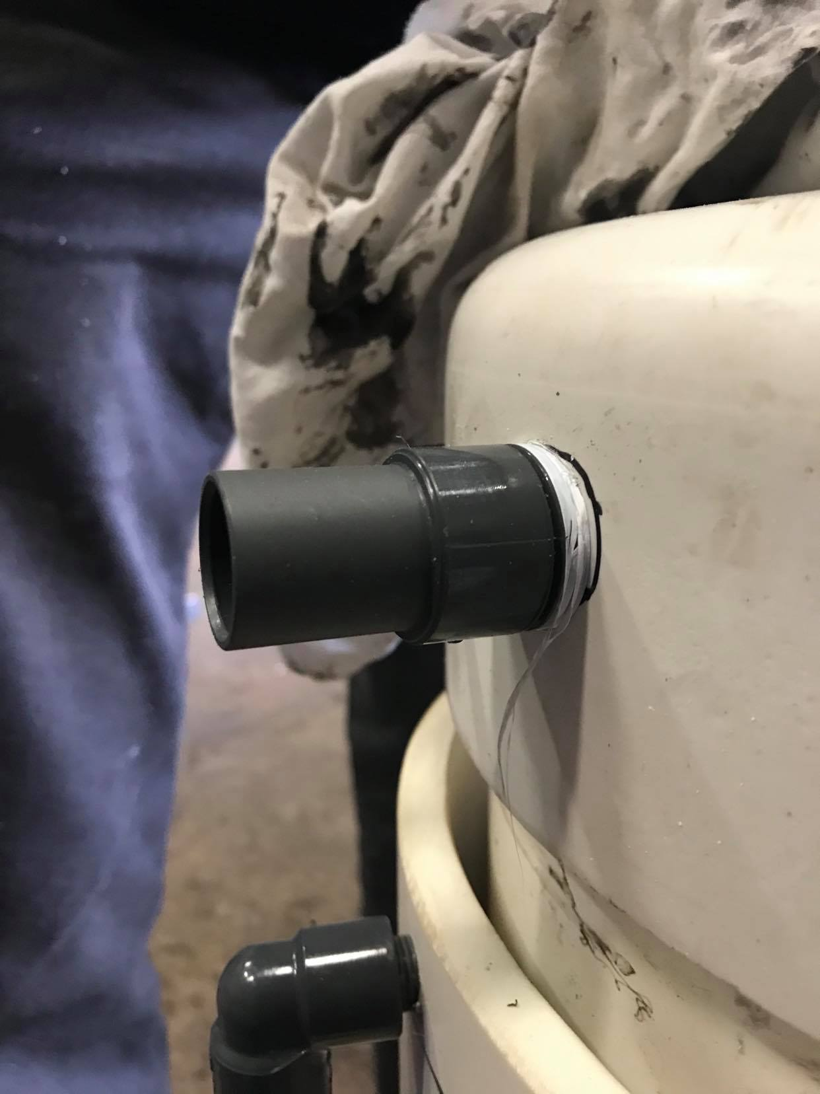

4. Drill a hole in the cap/**top** of pipe **#1** to accommodate the 2” PVC pipe (~outside diameter is 2.375”).

a. Insert tube so that base of tube is 2cm above the open **base** of the pipe and 7cm above the cap (**top**) of the pipe (total length 68cm).

b. Glue tube in place using pipe cement.

c. Cut the bottom tube to be serrated. *This helps prevent large bubbles forming and bubbling over the system.*

d. \**This tube will be used to allow excess air to escape the system, prevent excess pressure being delivered to the patient and causing barotrauma. Top and bottom view of pipe* ***#1.***

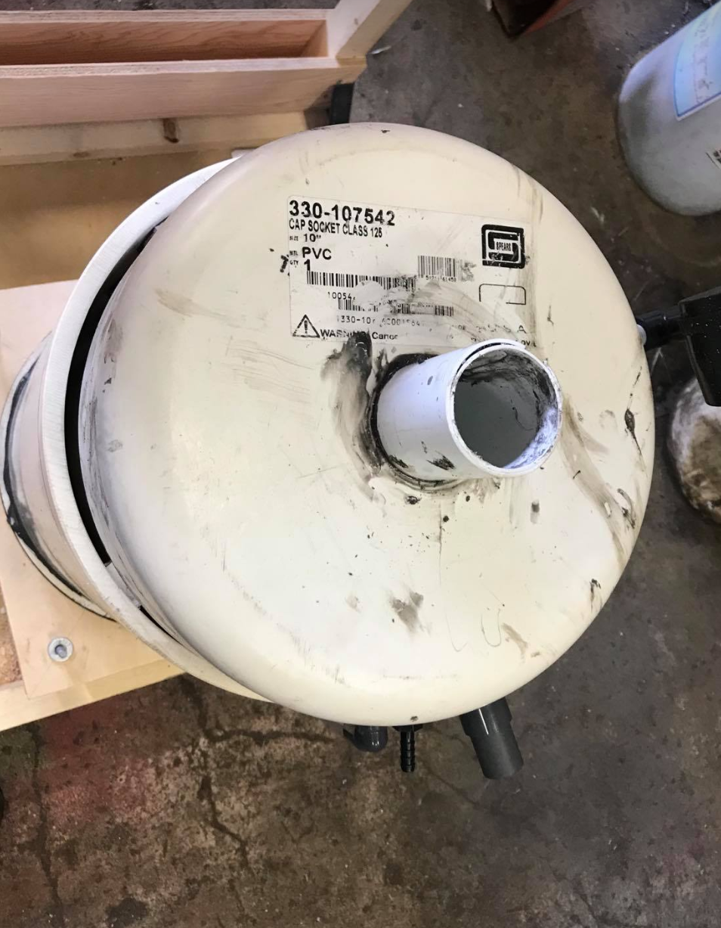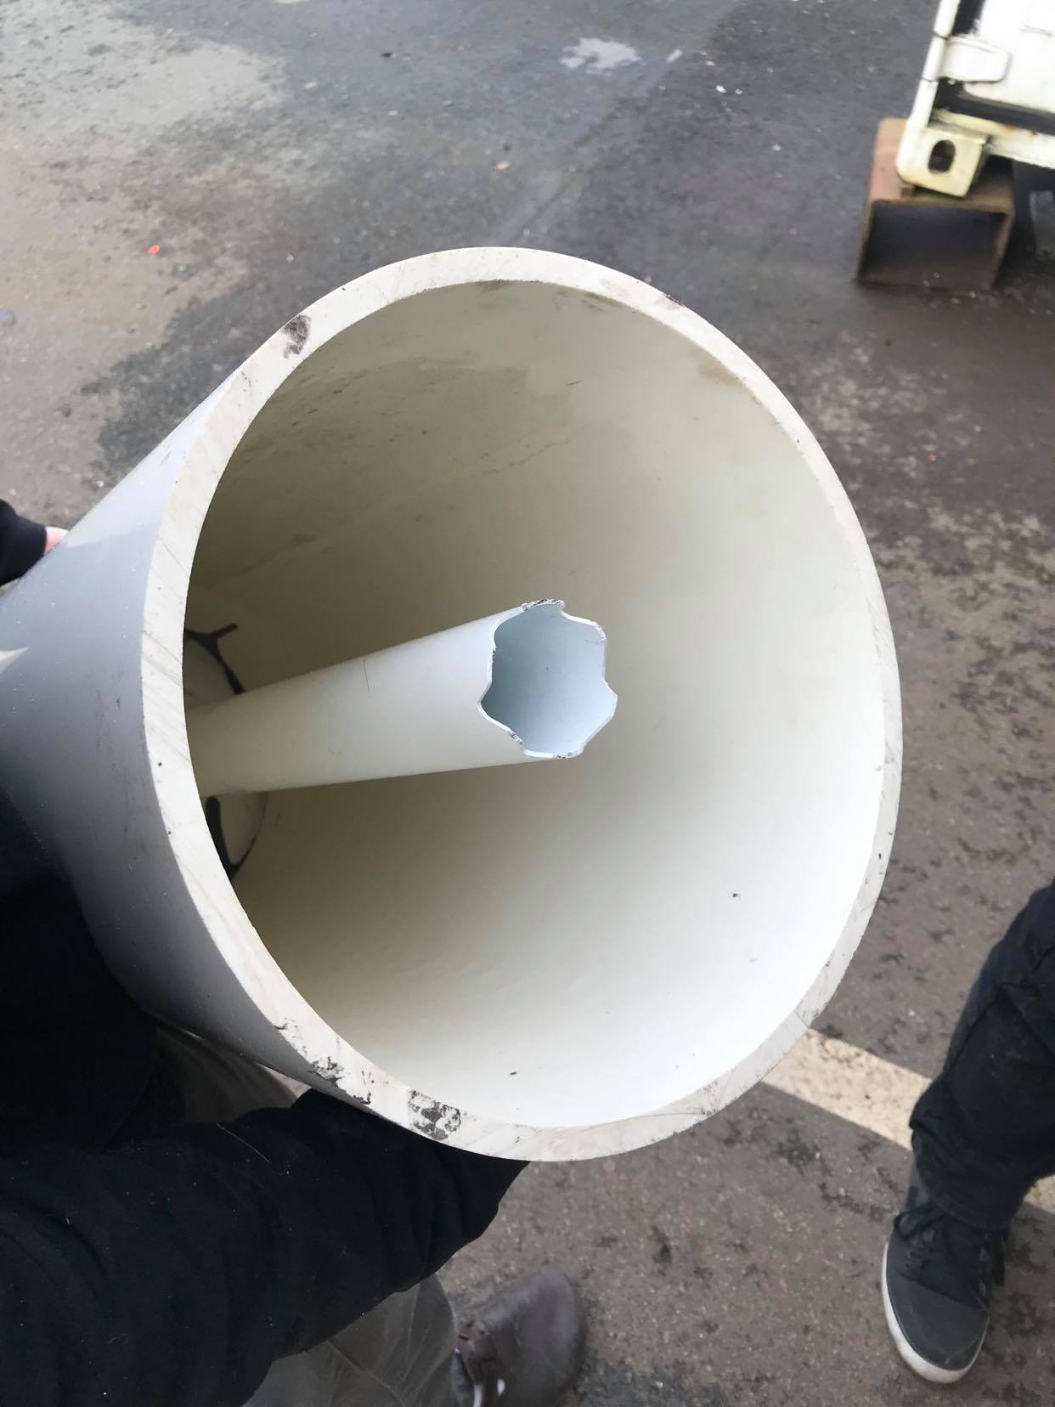

5. Drill and tap a ¼” hole in the side of the cap/**top** ~1-2cm from the top in pipe **#1.**

a. Thread PVC ¼” 90 degree elbow into the hole, using Teflon tape.

b. Thread PVC ½” x 3” nipple into the elbow, using Teflon tape.

c. Thread the manometer on the 3” nipple, using Teflon tape.

d. \**This allows for direct measurement of the pressure within the ventilator.*

*.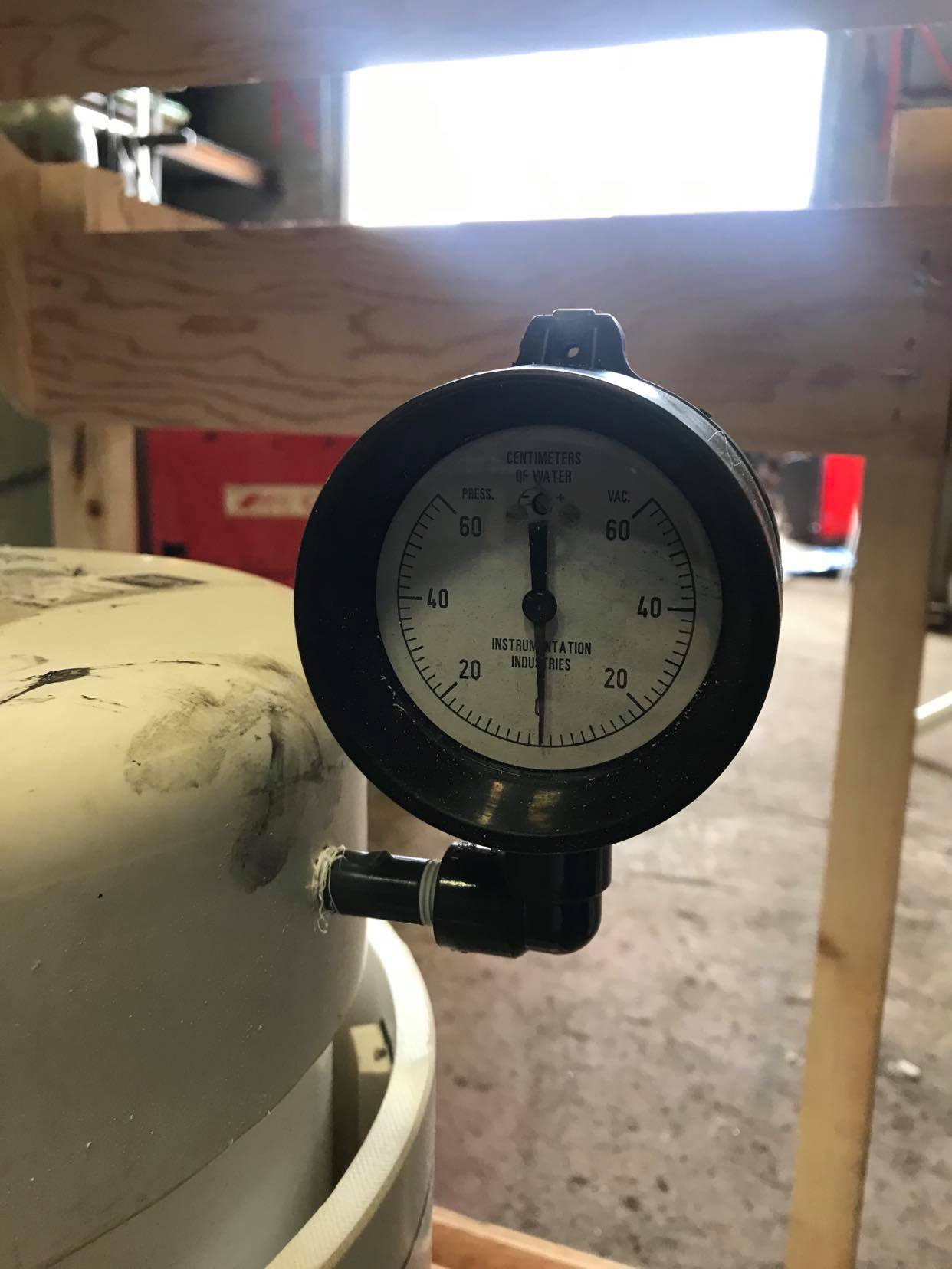*

Pipe **#2** (12” diameter, accommodates the smaller pipe):

1. Glue a 12” cap onto one end of the pipe using pipe cement. This end is now the **base / bottom** of this pipe.



2. Drill and tap 2 x ¼” holes 2-3cm above the **base** of pipe **#2** (through the side of the cap), ~10cm apart.

a. Thread in a PVC ¼” thread to ¼” hose barb nipple, using Teflon tape.

b. \**These ports will be used to connect the system to the pump and UV sterilization unit.*

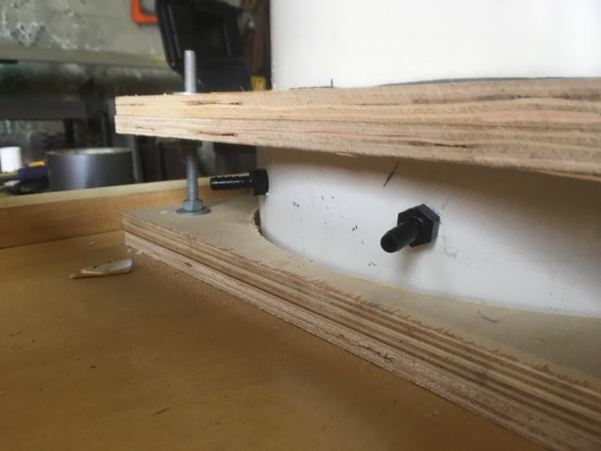

3. Drill and tap a ¼” hole 2-3cm from above the **base** of pipe **#2** (through the side of the cap) AND another ¼” hole directly inline above it, 2-3cm from the **top** of pipe **#2.**

a. Thread in a PVC ¼” threaded elbow & ¼” extender (¾” length) to each hole, using Teflon tape.

b. Measure from the bottom of the system (on the inside) and place markings on the clear ¼’ PVC pipe (measurements in cm).

c. Attach the clear ¼” PVC pipe between these two fittings.

d. \**This will act as a sight glass, and allow us to monitor the water level within the system.*

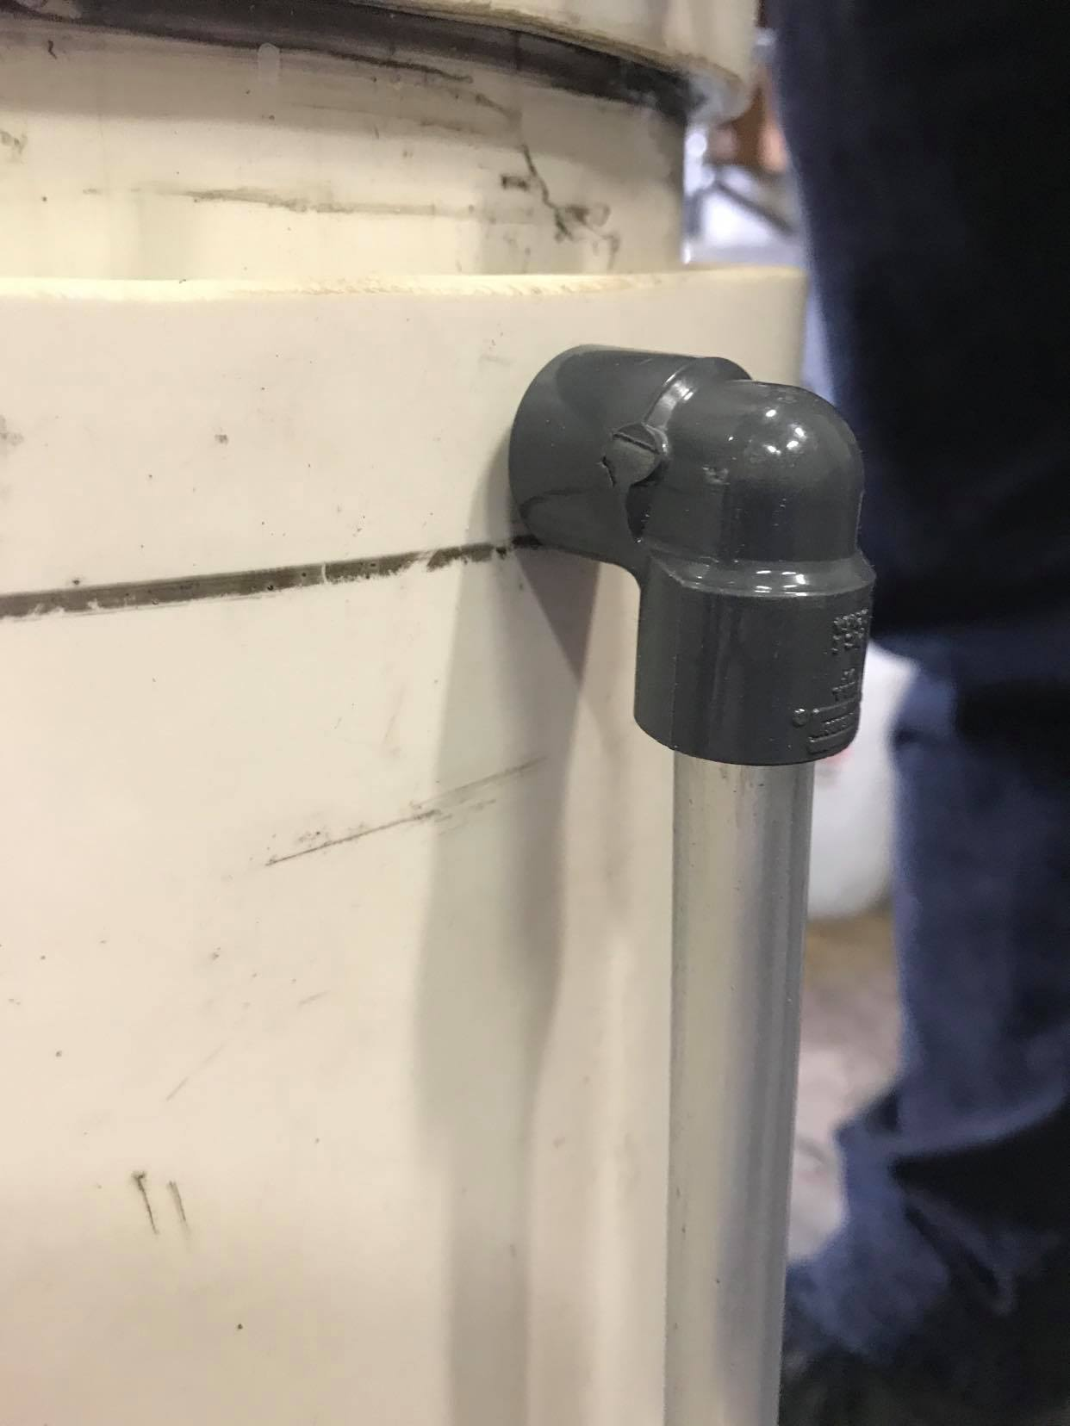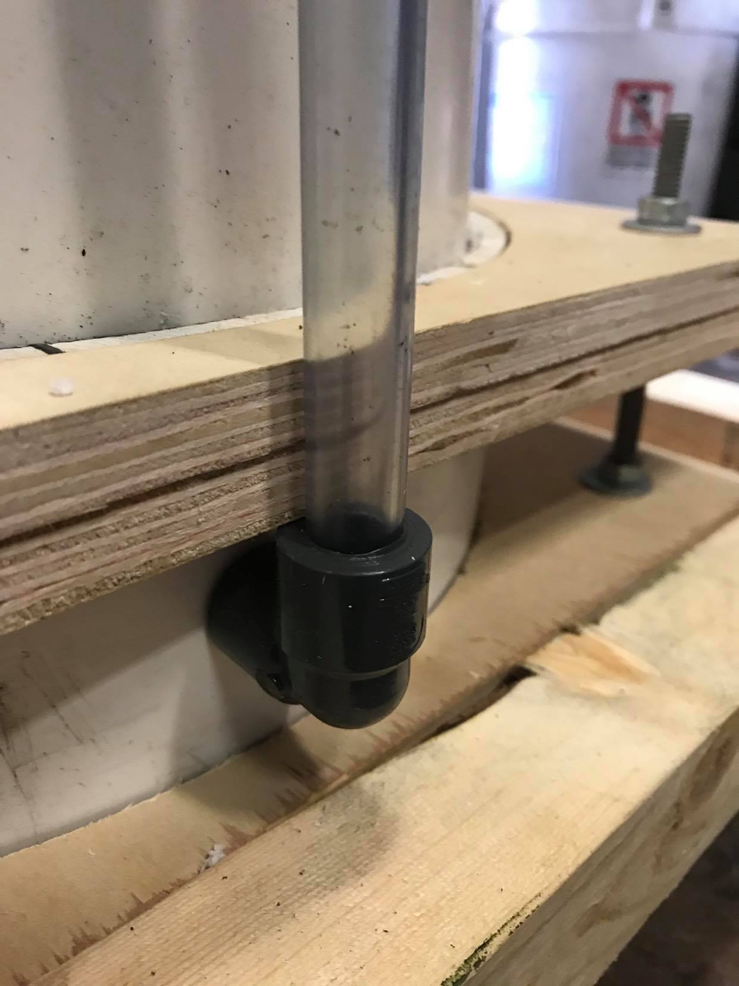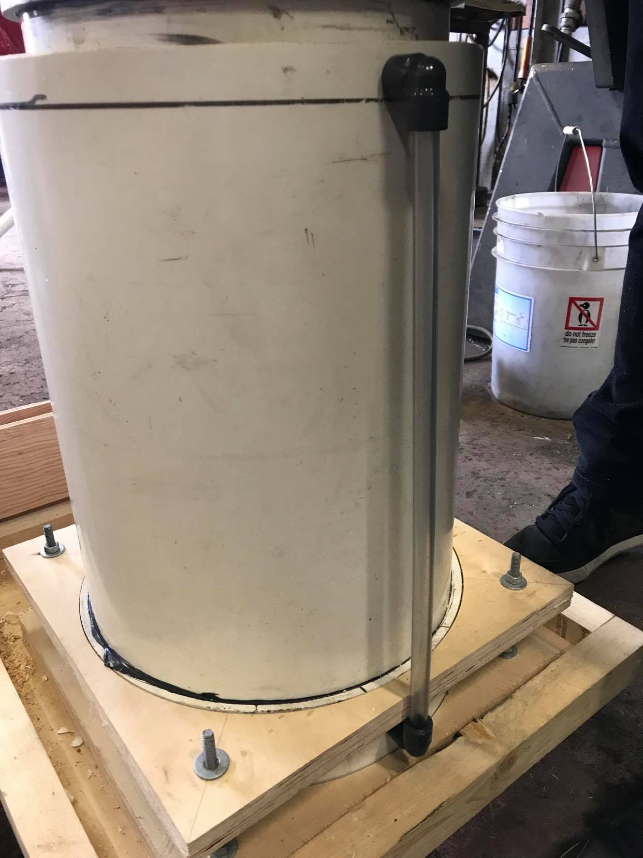

**Assembling the unit:**

1. Place pipe **#1** inside pipe **#2**, as pictured.

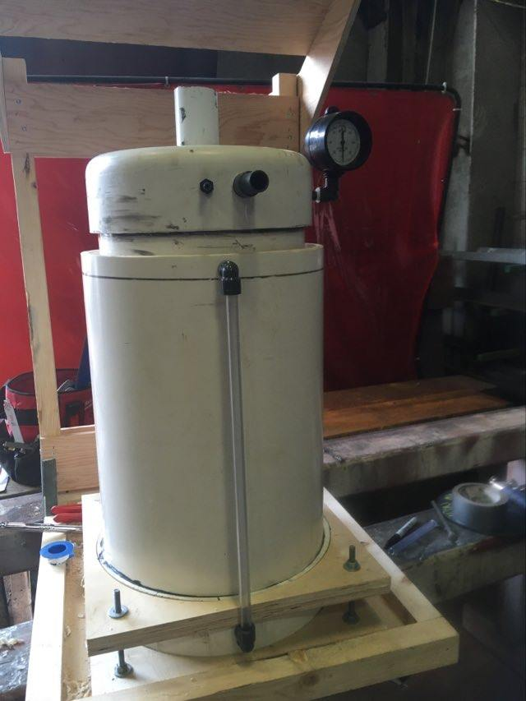

2. Connect the UV sterilizer and water pump in parallel to the barbs on the lower pipe

3. Add ~8L of water, until the level in the sight glass is at ~5cm.

**Circuit system (coding):**

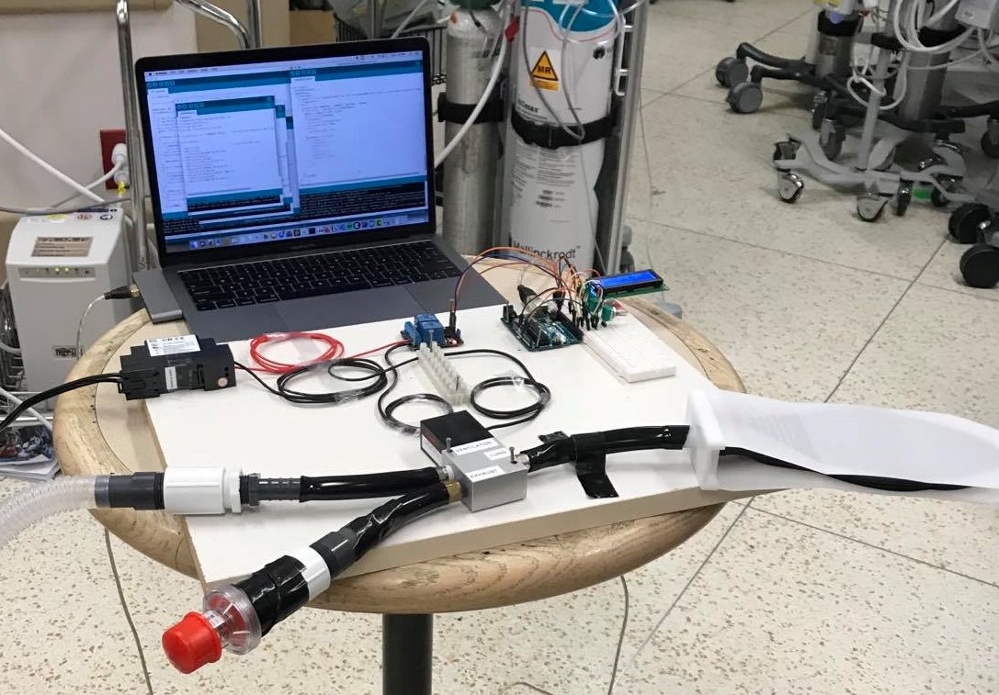

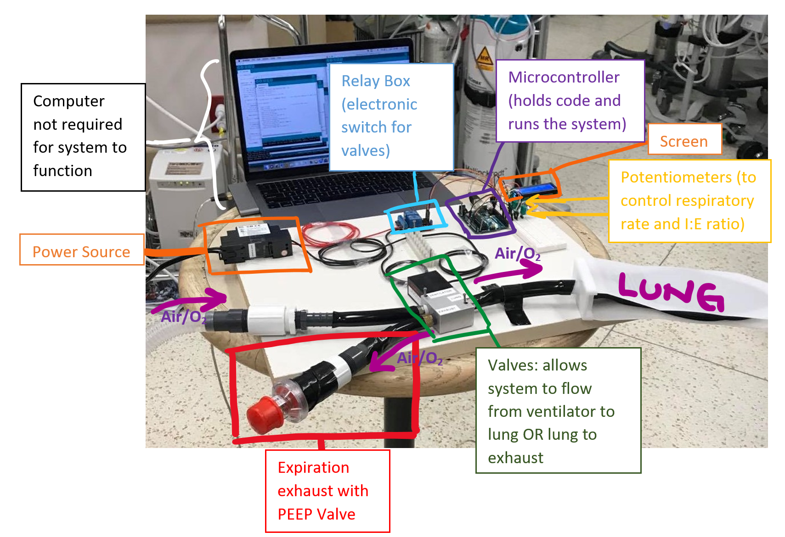

**For assembly of the circuit, please see the circuit diagram.**

In short, 22mm tubing attaches to the 22mm port in pipe **#1** and attaches to the valve system. The tubing from the intubated patient also attaches to this valve system. Finally, 22mm tubing attaches the valve system to the PEEP valve.

Once all the tubing is connected, turn the circuit on and turn on the flow from the wall (at approximately 8-10L/min). This should start and continue to run the system.